PawTrack
Database Design Document
Revision 2 — Visit Booking, Multi-Branch, AI scope reduced to Chatbot + Description Generation

1. What Changed in This Revision
• Removed — AIMatchScore and AIPhotoAnalysis entities — AI adopter-animal matching and AI photo-based breed/species recognition are dropped from scope as too complex for now.
• Added — Visit Booking domain — VisitSlot and VisitBooking entities support "book a slot, visit, then decide" instead of reserving an animal for one adopter indefinitely.
• Added — Multi-Branch support — a new Branch entity, with Animal, User and VisitSlot all scoped to a branch, since this system is built for an organization that may run multiple shelter locations across regions.
On your question — yes, it's worth designing for multiple branches now. Retrofitting a branch concept after animals, staff and adoption history already exist tends to be a much larger migration than including it from the start, even if you only launch with one branch initially. The change below is additive: a nullable/optional branch scope on the entities that need it, not a redesign.

2. Design Principles
• No long-held reservations — Animal.Status stays "Available" through the visit-booking process. Multiple adopters can book different visit slots for the same animal; nothing locks it to one person until an actual AdoptionApplication is submitted and moves forward.
• Branch-scoped, not branch-siloed — Animal, User and VisitSlot each carry a BranchId, but Category (species/breed) stays shared/global across branches, and an Admin's BranchId can be left null to mean "all branches" rather than duplicating admin accounts per branch.
• Visit is optional evidence, not a gate — AdoptionApplication.VisitBookingId is nullable — most adopters will visit first, but the workflow doesn't hard-require it.
• Nullable optional FKs elsewhere — Payment.AdoptionId / AnimalId stay nullable as before — a row is either an adoption-fee payment or a donation.
• Reserved-for-future field kept — Animal.MicrochipNumber remains in the schema (nullable) for the microchip registry integration you're holding for later.

3. Entity Overview
Entity | Domain | Purpose
Branch | Organization | A shelter/rescue location the organization operates.
User | Core | All accounts: Org Admin, Branch Admin, Rescue Staff, Veterinarian, Adopter.
Category | Core | Species/breed grouping used to classify animals (shared across branches).
Animal | Core | Rescued animal profile, rescue details, current status, home branch.
MedicalRecord | Core | Diagnosis, treatment and vaccination history per animal.
BehaviorRecord | Core | Temperament and compatibility assessment per animal.
VisitSlot | Visit & Scheduling | A bookable time window at a branch for adopters to visit.
VisitBooking | Visit & Scheduling | An adopter's booking of a slot to see a specific animal.
AdoptionApplication | Core | An adopter's request to adopt a specific animal (optionally linked to a visit).
Adoption | Core | The finalized adoption once an application is approved.
FollowUp | Core | Post-adoption check-in records.
Payment | Payment | Adoption-fee payments and donations (one ledger, typed).
AIGeneratedDescription | AI | AI-drafted animal profile text, pending staff approval.
ChatbotConversation / ChatbotMessage | AI | Adopter-facing chatbot session and message log.

4. Entity-Relationship Diagram
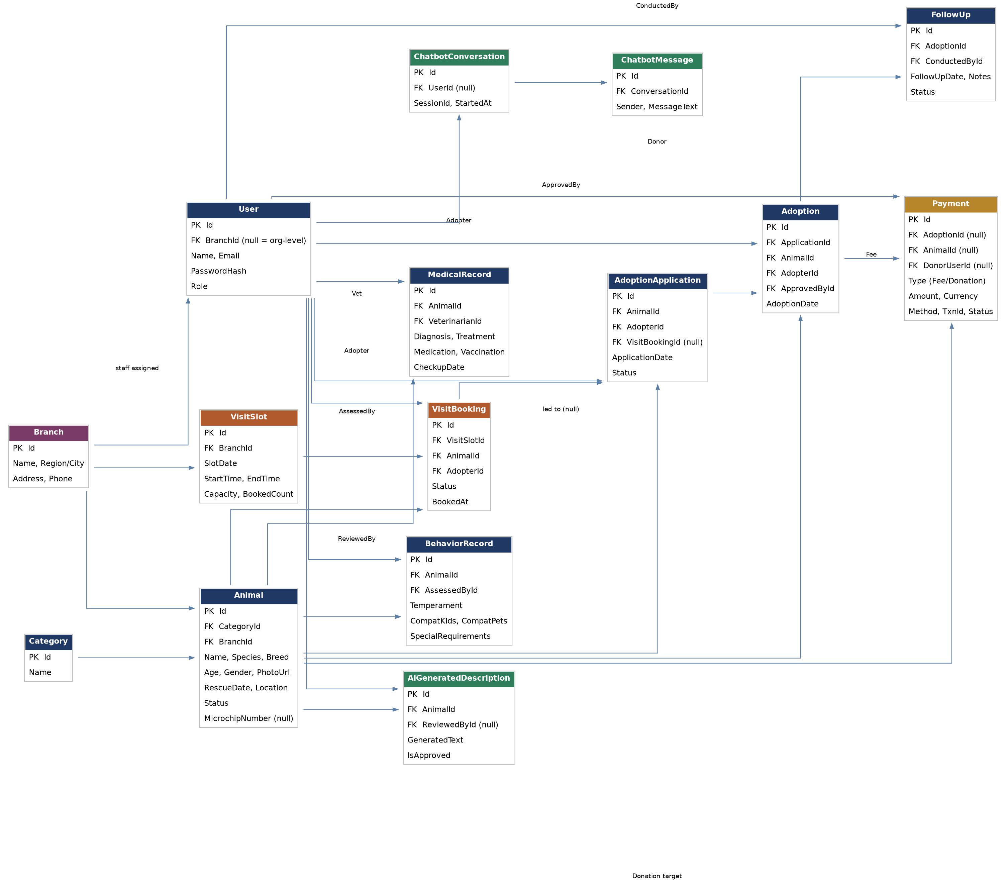
Purple = organization/branch · Blue = core lifecycle · Orange = visit scheduling · Gold = payment/donation · Green = AI-generated data.

5. Detailed Table Schemas
5.1 Organization Domain
Branch
Field | Type | Constraints / Notes
Id | int, PK | Auto-increment
Name | nvarchar(120) | Required, e.g. "PawTrack — Downtown Shelter"
Region / City | nvarchar(100) | Required; used for filtering and reporting
Address | nvarchar(250) | Required
Phone | nvarchar(30) | Optional
5.2 Core Lifecycle Domain
User
Field | Type | Constraints / Notes
Id | int, PK | Auto-increment
BranchId | int, FK → Branch, nullable | Null = organization-level account (e.g. Org Admin); set = scoped to one branch
Name | nvarchar(100) | Required
Email | nvarchar(150) | Required, unique
PasswordHash | nvarchar(256) | Required
Role | enum | OrgAdmin | BranchAdmin | RescueStaff | Veterinarian | Adopter
CreatedAt | datetime2 | Default: current timestamp
Category
Field | Type | Constraints / Notes
Id | int, PK | Auto-increment
Name | nvarchar(80) | Required, e.g. Dog, Cat, Bird — shared across all branches
Animal
Field | Type | Constraints / Notes
Id | int, PK | Auto-increment
CategoryId | int, FK → Category | Required
BranchId | int, FK → Branch | Required — the shelter location currently holding the animal
Name | nvarchar(100) | Required
Species / Breed | nvarchar(80) each | Required
Age / Gender | int / enum | Required
PhotoUrl | nvarchar(300) | Optional; blob storage reference
RescueDate / RescueLocation | date / nvarchar(200) | Required
Status | enum | UnderAssessment | Available | Pending | Adopted
MicrochipNumber | nvarchar(50), nullable | Reserved for future microchip registry integration
MedicalRecord
Field | Type | Constraints / Notes
Id | int, PK | Auto-increment
AnimalId | int, FK → Animal | Required
VeterinarianId | int, FK → User | Required
Diagnosis | nvarchar(500) | Required
Treatment / Medication | nvarchar(500) each | Optional
VaccinationDate / CheckupDate | date | Optional / Required
BehaviorRecord
Field | Type | Constraints / Notes
Id | int, PK | Auto-increment
AnimalId | int, FK → Animal | Required
AssessedById | int, FK → User | Required
Temperament | nvarchar(200) | Required
CompatibilityWithKids / Pets | bool | Required
SpecialRequirements | nvarchar(300) | Optional

5.3 Visit & Scheduling Domain
VisitSlot
Field | Type | Constraints / Notes
Id | int, PK | Auto-increment
BranchId | int, FK → Branch | Required — a branch defines its own visiting hours/slots
SlotDate | date | Required
StartTime / EndTime | time | Required
Capacity | int | Max simultaneous bookings for this slot
BookedCount | int | Running count; slot closes to new bookings once BookedCount = Capacity
VisitBooking
Field | Type | Constraints / Notes
Id | int, PK | Auto-increment
VisitSlotId | int, FK → VisitSlot | Required
AnimalId | int, FK → Animal | Required — the specific animal the adopter wants to see
AdopterId | int, FK → User | Required
Status | enum | Booked | CheckedIn | Completed | Cancelled | NoShow
BookedAt | datetime2 | Default: current timestamp
Notes | nvarchar(300) | Optional staff notes after the visit
Booking a visit never changes Animal.Status — it stays "Available" so other adopters can keep booking or applying. Only a submitted, approved AdoptionApplication moves the animal to Pending/Adopted, which is the point where remaining open bookings for that animal would be flagged for staff to follow up.
5.4 Adoption Domain (updated)
AdoptionApplication
Field | Type | Constraints / Notes
Id | int, PK | Auto-increment
AnimalId | int, FK → Animal | Required
AdopterId | int, FK → User | Required
VisitBookingId | int, FK → VisitBooking, nullable | Set when the application follows a visit; null if the adopter applied without one
ApplicationDate | datetime2 | Default: current timestamp
Status | enum | Pending | Approved | Rejected
Adoption
Field | Type | Constraints / Notes
Id | int, PK | Auto-increment
ApplicationId | int, FK → AdoptionApplication | Required, unique
AnimalId | int, FK → Animal | Required
AdopterId | int, FK → User | Required
ApprovedById | int, FK → User | Required (Branch Admin/Rescue Staff)
AdoptionDate | date | Required
FollowUp
Field | Type | Constraints / Notes
Id | int, PK | Auto-increment
AdoptionId | int, FK → Adoption | Required
ConductedById | int, FK → User | Required
FollowUpDate | date | Required
Notes / Status | nvarchar(500) / enum | Required

5.5 Payment & Donation Domain
Payment
Field | Type | Constraints / Notes
Id | int, PK | Auto-increment
Type | enum | AdoptionFee | Donation
AdoptionId | int, FK → Adoption, nullable | Set only when Type = AdoptionFee
AnimalId | int, FK → Animal, nullable | Optional; lets a donor target a specific animal's care
DonorUserId | int, FK → User, nullable | Null allowed for one-off/guest donations
Amount / Currency | decimal(10,2) / char(3) | Required
PaymentMethod | nvarchar(50) | Card, UPI, wallet, etc. (per gateway)
TransactionId | nvarchar(100) | Gateway reference, unique
Status | enum | Pending | Completed | Failed | Refunded
PaymentDate | datetime2 | Set when Status = Completed
No card or bank details are stored here — only the gateway's transaction reference and status.
5.6 AI Domain (reduced scope)
AIGeneratedDescription
Field | Type | Constraints / Notes
Id | int, PK | Auto-increment
AnimalId | int, FK → Animal | Required
GeneratedText | nvarchar(max) | Draft adoption-profile copy
ModelVersion | nvarchar(30) | Tracks which model produced the text
IsApproved | bool | Default false; staff must approve before it's shown publicly
ReviewedById | int, FK → User, nullable | Set when a staff member approves/edits it
ChatbotConversation
Field | Type | Constraints / Notes
Id | int, PK | Auto-increment
UserId | int, FK → User, nullable | Null for anonymous site visitors
SessionId | nvarchar(64) | Groups messages for a browser/app session
StartedAt | datetime2 | Default: current timestamp
ChatbotMessage
Field | Type | Constraints / Notes
Id | int, PK | Auto-increment
ConversationId | int, FK → ChatbotConversation | Required
Sender | enum | User | Bot
MessageText | nvarchar(max) | Required
Timestamp | datetime2 | Default: current timestamp

6. Relationship Summary
• Branch (1) → (many) Animal, User (staff), VisitSlot
• Category (1) → (many) Animal
• Animal (1) → (many) MedicalRecord, BehaviorRecord, VisitBooking, AdoptionApplication, AIGeneratedDescription
• VisitSlot (1) → (many) VisitBooking
• VisitBooking (0..1) → (0..1) AdoptionApplication — an application may reference the visit that led to it
• AdoptionApplication (1) → (1) Adoption, on approval
• Adoption (1) → (many) FollowUp; (1) → (0..1) Payment of type AdoptionFee
• Animal (1) → (many) Payment of type Donation (optional target)
• User (1) → (many) MedicalRecord (Vet), BehaviorRecord (Assessor), VisitBooking (Adopter), AdoptionApplication (Adopter), Adoption (Adopter/Approver), FollowUp (Conductor), Payment (Donor), AIGeneratedDescription (Reviewer), ChatbotConversation
• ChatbotConversation (1) → (many) ChatbotMessage

7. Future Extension Points (design-ready, not built now)
• Mobile app — no schema change — calls the same branch-aware APIs as the web client.
• Microchip registry — Animal.MicrochipNumber already exists (nullable).
• Petfinder / Adopt-a-Pet sync — would add one ExternalListingSync table (AnimalId, Provider, ExternalId, LastSyncedAt) — additive only.
• AI matching / photo recognition, if revisited later — the AI domain already models AI output as reviewable data (see AIGeneratedDescription); an AIMatchScore or AIPhotoAnalysis table could be added the same way without touching existing tables — worth reconsidering as a simpler rule-based filter first, before a full ML model.

